I’ve been working on a package that closely mirrors that of [***GAMSEL (generalized additive model selection)***](https://arxiv.org/pdf/1506.03850.pdf), a method for fitting sparse generalized additive models (GAMs). In preparing my package, I realized that (i) the gamsel package which implements GAMSEL doesn’t have a vignette, and (ii) I could modify the vignette for my package minimally to create one for gamsel. So here it is!

**Introduction**

GAMSEL (Generalized Additive Model Selection), a penalized likelihood approach for fitting sparse generalized additive models in high dimension. Our method interpolates between null, linear and additive models by allowing the effect of each variable to be estimated as being either zero, linear, or a low-complexity curve, as determined by the data. We present a blockwise coordinate descent procedure for efficiently optimizing the penalized likelihood objective over a dense grid of the tuning parameter, producing a regularization path of additive models. We demonstrate the performance of our method on both real and simulated data examples, and compare it with existing techniques for additive model selection.

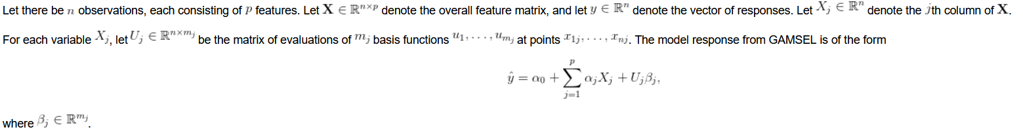

Let there be nobservations, each consisting of pfeatures. Let denote the overall feature matrix, and let denote the vector of responses. Let denote the jth column of .

For each variable X_j, let be the matrix of evaluations of m_jbasis functions at points . The model response from GAMSEL is of the form

where .

**The gamsel() function**

The purpose of this section is to give users a general sense of the gamsel() function, which is probably the most important function of the package. First, we load the gamsel package:

library(gamsel)

#> Loading required package: foreach

#> Loading required package: mda

#> Loading required package: class

#> Loaded mda 0.4-10

#> Loaded gamsel 1.8-1

Let’s generate some data:

set.seed(1)

n <- 100; p <- 12

x = matrix(rnorm((n) \* p), ncol = p)

f4 = 2 \* x[,4]^2 + 4 \* x[,4] - 2

f5 = -2 \* x[, 5]^2 + 2

f6 = 0.5 \* x[, 6]^3

mu = rowSums(x[, 1:3]) + f4 + f5 + f6

y = mu + sqrt(var(mu) / 4) \* rnorm(n)

We fit the model using the most basic call to gamsel():

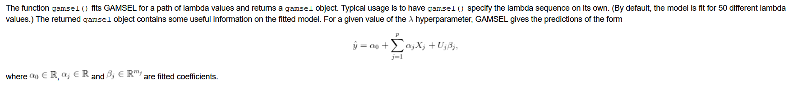

fit <- gamsel(x, y)

The function gamsel() fits GAMSEL for a path of lambda values and returns a gamsel object. Typical usage is to have gamsel() specify the lambda sequence on its own. (By default, the model is fit for 50 different lambda values.) The returned gamsel object contains some useful information on the fitted model. For a given value of the hyperparameter, GAMSEL gives the predictions of the form

where , and are fitted coefficients.

Printing the returned gamsel object tells us how many features, linear components and non-linear components were included in the model for each lambda value respectively. It also shows the fraction of null deviance explained by the model and the lambda value for that model.

fit

#>

#> Call: gamsel(x = x, y = y)

#>

#> NonZero Lin NonLin %Dev Lambda

#> [1,] 0 0 0 0.00000 80.1300

#> [2,] 1 1 0 0.03693 72.9400

#> [3,] 1 1 0 0.06754 66.4000

#> [4,] 1 1 0 0.09290 60.4400

#> [5,] 1 1 0 0.11390 55.0200

#> [6,] 1 1 0 0.13130 50.0900

#> [7,] 1 1 0 0.14580 45.5900

#> .... (redacted for conciseness)

gamsel has a tuning parameter gamma which is between 0 and 1. Smaller values of gamma penalize the linear components less than the non-linear components, resulting in more linear components for the fitted model. The default value is gamma = 0.4.

fit2 <- gamsel(x, y, gamma = 0.8)

By default, each variable is given basis functions. This can be modified with the degrees option, and this value can differ from variable to variable (to allow for this, pass a vector of length equal to the number of variables to the degrees option).

By default, the maximum degrees of freedom for each variable is 5. This can be modified with the dfs option, with larger values allowing more “wiggly” fits. Again, this value can differ from variable to variable.

**Predictions**

Predictions from this model can be obtained by using the predict method of the gamsel() function output: each column gives the predictions for a value of lambda.

# get predictions for all values of lambda

all\_predictions <- predict(fit, x) dim(all\_predictions) #> [1] 100 50

# get predictions for 20th model for first 5 observations

all\_predictions[1:5, 20]

#> [1] 1.88361056 -4.47189543 8.05935149 -0.04271584 5.93270321

One can also specify the lambda indices for which predictions are desired:

# get predictions for 20th model for first 5 observations

predict(fit, x[1:5, ], index = 20)

#> l20

#> [1,] 1.88361056

#> [2,] -4.47189543

#> [3,] 8.05935149

#> [4,] -0.04271584

#> [5,] 5.93270321

The predict method has a type option which allows it to return different types of information to the user. type = "terms" gives a matrix of fitted functions, with as many columns as there are variables. This can be useful for understanding the effect that each variable has on the response. Note that what is returned is a 3-dimensional array!

# effect of variables for first 10 observations and 20th model

indiv\_fits <- predict(fit, x[1:10, ], index = c(20), type = "terms") dim(indiv\_fits) #> [1] 10 1 12

# effect of variable 4 on these first 10 observations

plot(x[1:10, 4], indiv\_fits[, , 4])

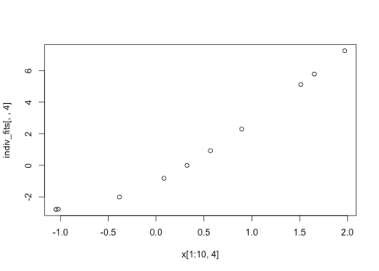

type = "nonzero" returns a list of indices of non-zero coefficients at a given lambda.

# variables selected by GAMSEL and the 10th and 50th lambda values

predict(fit, x, index = c(10, 50), type = "nonzero")

#> $l10

#> [1] 2 3 4 5 6

#>

#> $l50

#> [1] 1 2 3 4 5 6 7 8 9 10 11 12

**Plots and summaries**

Let’s fit the basic gamsel model again:

fit <- gamsel(x, y)

fit is a class “gamsel” object which comes with a plot method. The plot method shows us the relationship our predicted response has with each input feature, i.e. it plots vs. X_jfor each j. Besides passing fit to the plot() call, the user must also pass an input matrix x: this is used to determine the coordinate limits for the plot. It is recommended that the user simply pass in the same input matrix that the GAMSEL model was fit on.

By default, plot() gives the fitted functions for the last value of the lambda key in fit, and gives plots for all the features. For high-dimensional data, this latter default is problematic as it will produce too many plots! You can pass a vector of indices to the which option to specify which features you want plots for. The code below gives plots for the first 4 features:

par(mfrow = c(1, 4))

par(mar = c(4, 2, 2, 2))

plot(fit, x, which = 1:4)

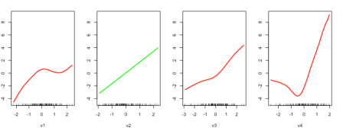

The user can specify the index of the lambda value to show using the index option:

# show fitted functions for x2, x5 and x8 at the model for the 15th lambda value

par(mfrow = c(1, 3))

plot(fit, x, index = 15, which = c(2, 5, 8))

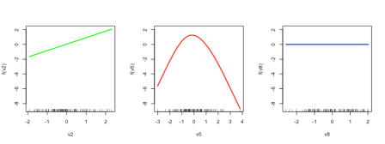

Linear functions are colored green, non-linear functions are colored red, while zero functions are colored blue.

Class “gamsel” objects also have a summary method which allows the user to see the coefficient profiles of the linear and non-linear features. On each plot (one for linear features and one for non-linear features), the x-axis is the value going from large to small. For linear components, the y-axis is the coefficient for each variable while for the nonlinear components, it is the norm of the nonlinear coefficients.

par(mfrow = c(1, 2))

summary(fit)

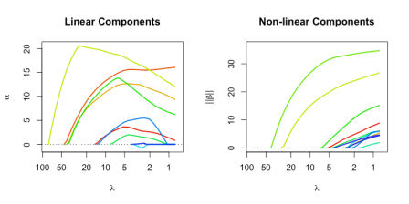

We can include annotations to show which profile belongs to which feature by specifying label = TRUE.

par(mfrow = c(1, 2))

summary(fit, label = TRUE)

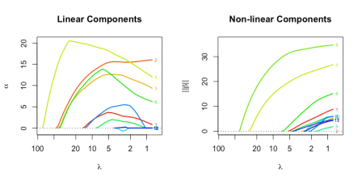

**Cross-validation**

We can perform k-fold cross-validation (CV) for GAMSEL with cv.gamsel(). It does 10-fold cross-validation by default:

cvfit <- cv.gamsel(x, y)

We can change the number of folds using the nfolds option:

cvfit <- cv.gamsel(x, y, nfolds = 5)

If we want to specify which observation belongs to which fold, we can do that by specifying the foldid option, which is a vector of length n, with the ith element being the fold number for observation i.

set.seed(3)

foldid <- sample(rep(seq(10), length = n))

cvfit <- cv.gamsel(x, y, foldid = foldid)

A cv.gamsel() call returns a cv.gamsel object. We can plot this object to get the CV curve with error bars (one standard error in each direction). The left vertical dotted line represents lambda.min, the lambda value which attains minimum CV error, while the right vertical dotted line represents lambda.1se, the largest lambda value with CV error within one standard error of the minimum CV error.

plot(cvfit)

The numbers at the top represent the number of features in our original input matrix that are included in the model.

The two special lambda values, as well as their indices in the lambda path, can be extracted directly from the cv.gamsel object:

# lambda values

cvfit$lambda.min

#> [1] 3.959832

cvfit$lambda.1se

#> [1] 8.39861

# corresponding lambda indices

cvfit$index.min

#> [1] 33

cvfit$index.1se

#> [1] 25

**Logistic regression with binary data**

In the examples above, y was a quantitative variable (i.e. takes values along the real number line). As such, using the default family = "gaussian" for gamsel() was appropriate. In theory, the GAMSEL algorithm is very flexible and can be used when y is not a quantitative variable. In practice, gamsel() has been implemented for binary response data. The user can use gamsel() (or cv.gamsel()) to fit a model for binary data by specifying family = "binomial". All the other functions we talked about above can be used in the same way.

In this setting, the response y should be a numeric vector containing just 0s and 1s. When doing prediction, note that by default predict() gives just the value of the linear predictors, i.e.

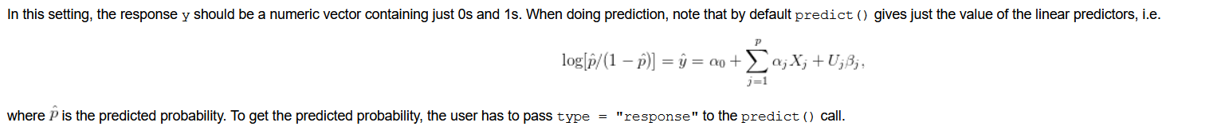

where is the predicted probability. To get the predicted probability, the user has to pass type = "response" to the predict() call.

# fit binary model

bin\_y <- ifelse(y > 0, 1, 0)

binfit <- gamsel(x, bin\_y, family = "binomial")

# linear predictors for first 5 observations at 10th model

predict(binfit, x[1:5, ])[, 10]

#> [1] 0.1293867 -0.4531994 0.4528493 -0.2539989 0.3576436

# predicted probabilities for first 5 observations at 10th model

predict(binfit, x[1:5, ], type = "response")[, 10]

#> [1] 0.5323016 0.3886003 0.6113165 0.4368395 0.5884699